A Flume agent is a (JVM) process that hosts the components through which events flow from an external source to the next destination (hop).

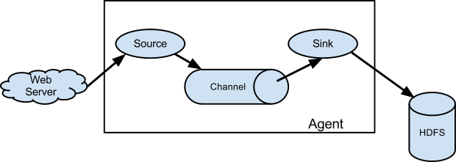**Procedure：**

1. A Flume **source** consumes events delivered to it by an external source like a web server. The external source sends events to Flume in a format that is recognized by the target Flume source. [Interceptor]
2. When a Flume source receives an event, it stores it into one or more **channels**. The channel is a passive store that keeps the event until it’s consumed by a Flume sink. [Selector]
3. The **sink** removes the event from the channel and puts it into an external repository like HDFS or forwards it to the Flume source of the next Flume agent (next hop) in the flow. [Processor]
4. The source and sink within the given agent run **asynchronously** with the events staged in the channel.

其实就是生产者-消费者模型